**Audit Application**

Azure database :

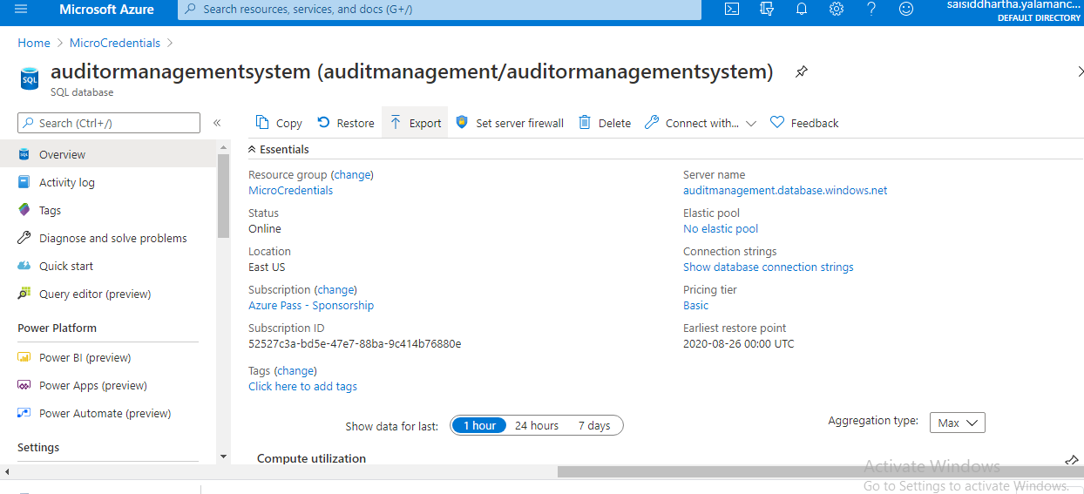

Audit App service :

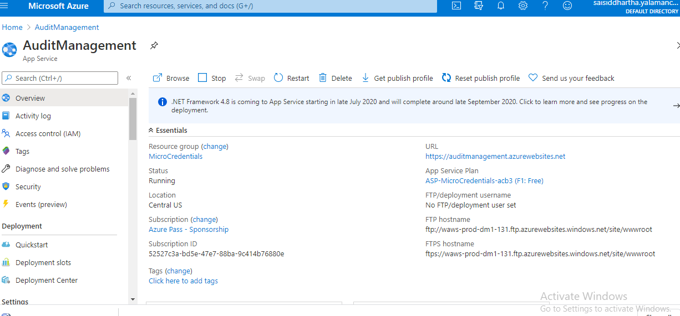

Client Database :

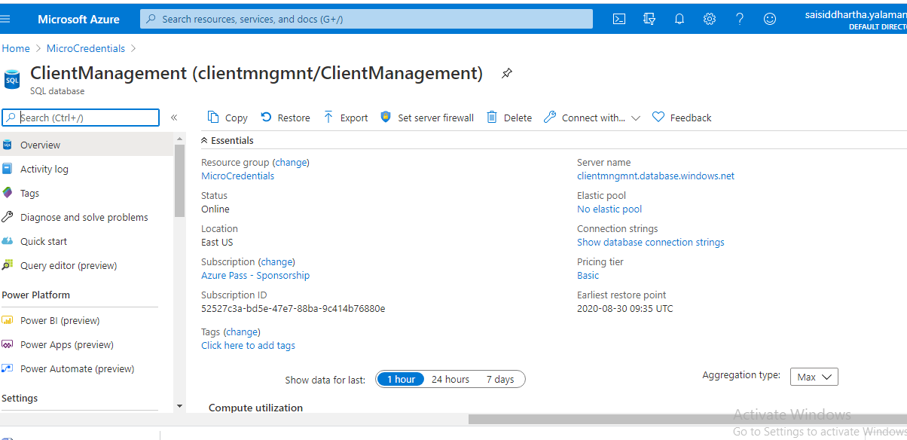

Client App service :

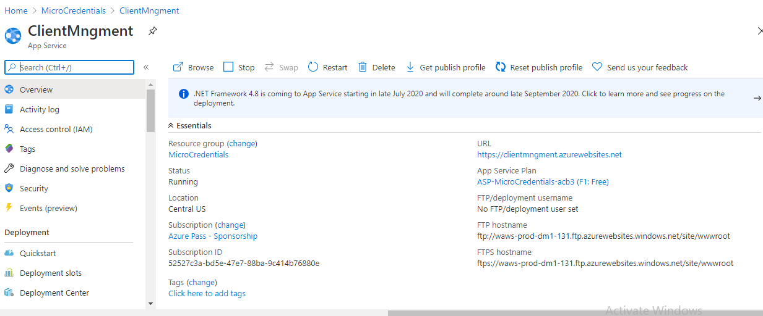

**Interaction between Audit Application and Client application**

A service bus was created to facilitate bi-directional communication / linkage between audit and client applications.

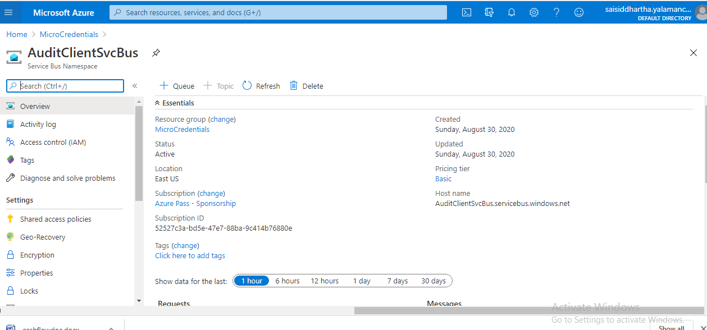

**Queues:**

**Audit to client communication :**

Auditor sends an request to the client asking for some details. The request (Audit request) goes to the AudittoClientQueue and waits there in the queue to be picked up.

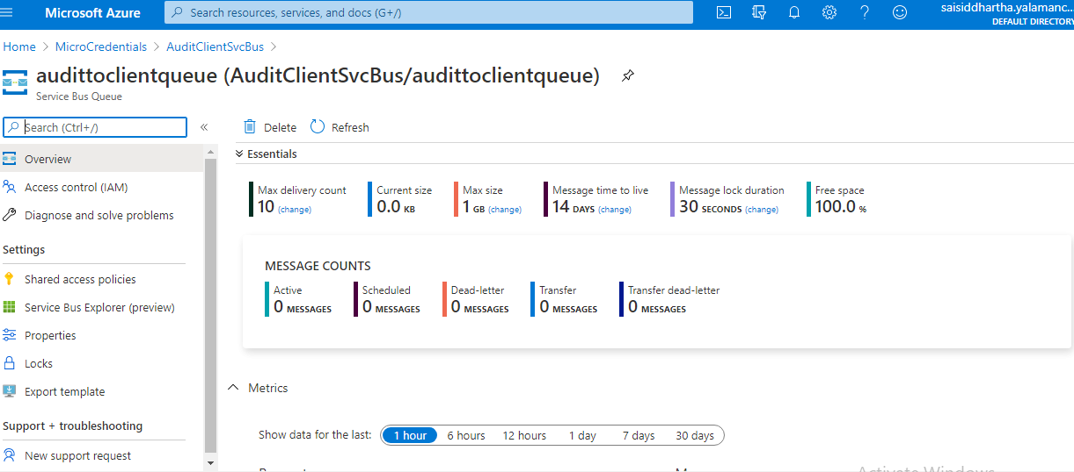

**Client to Audit Communication :**

Client response to the auditor by creating necessary documents and puts the message in the queue for Auditor to pick it up.

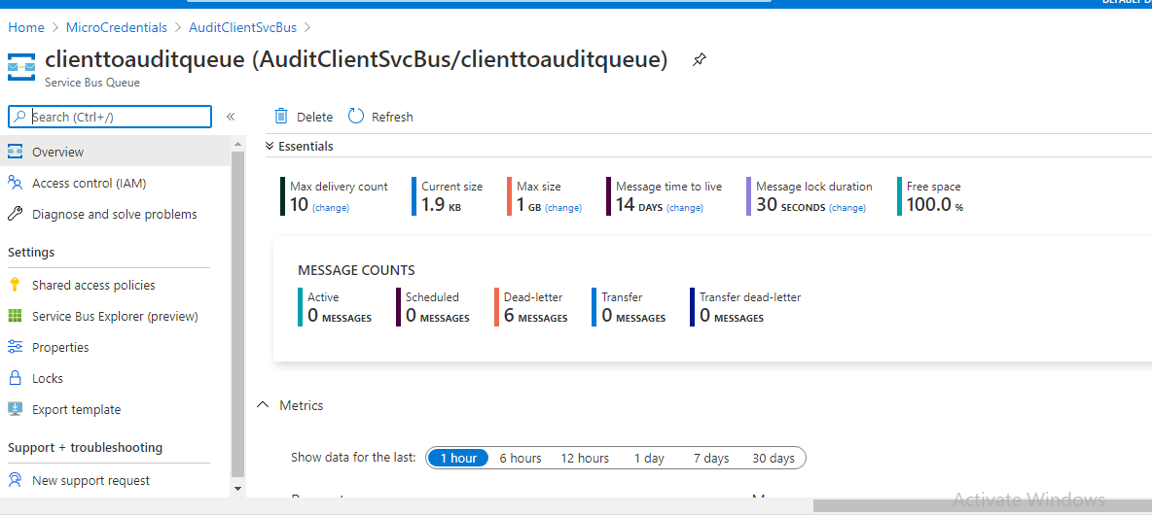

**How Client and Audit Picks message from the Queue :**

Audit and clients post their messages to the queue. So I’ve created a function apps to do the pick up job.

**Azure Functions :**

AudittoclientQueueTrigger :

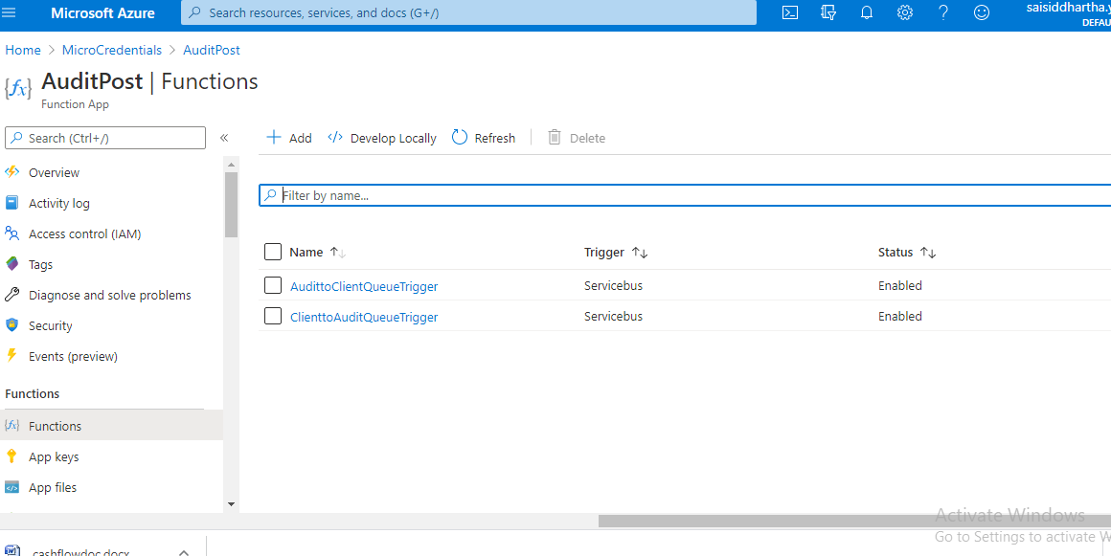

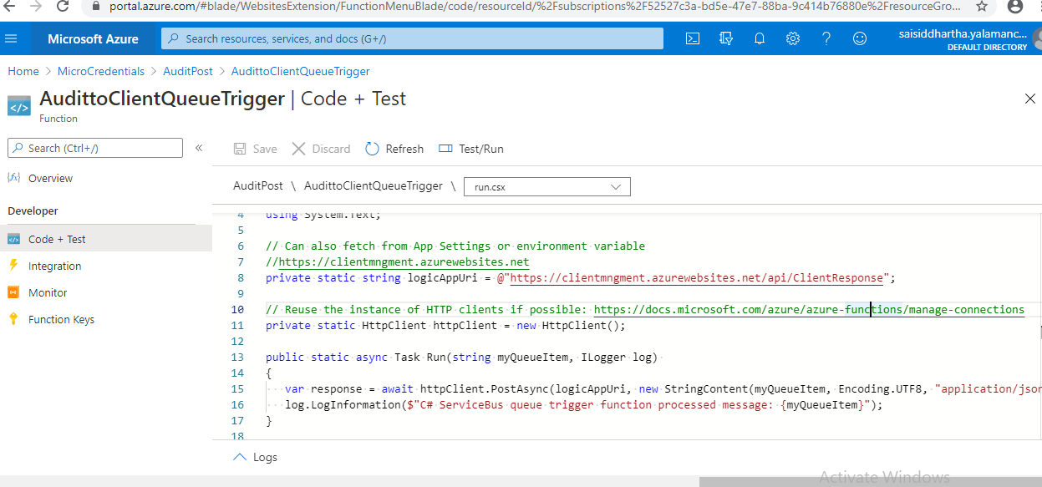

The piece of code in the img does a asynchrous post request to the client application and insert into client db.

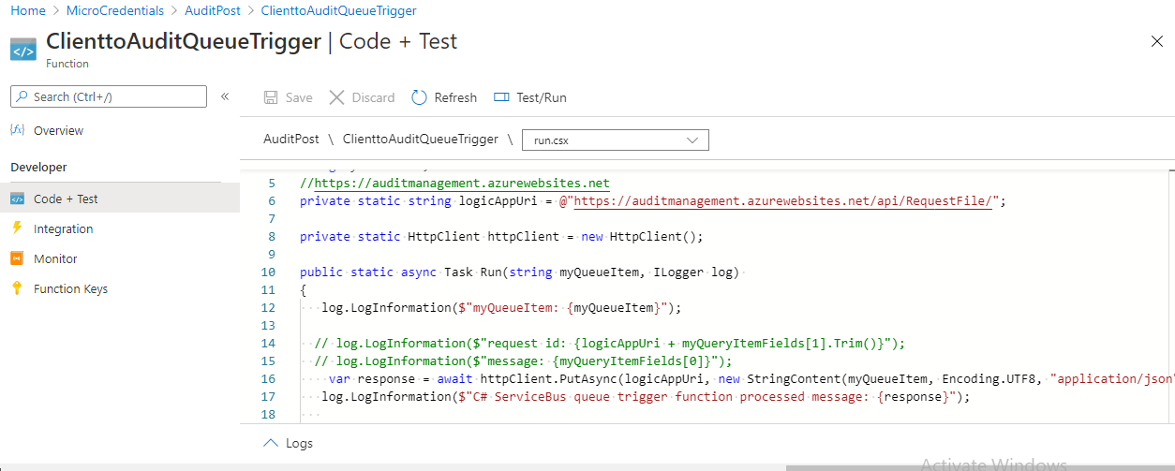

The piece of code in Azurefunction does asyncput (update the audit request with client response) and insert into the databse.

**Blob storage :**

Created a storage account and a blob container to add the docs to the client.

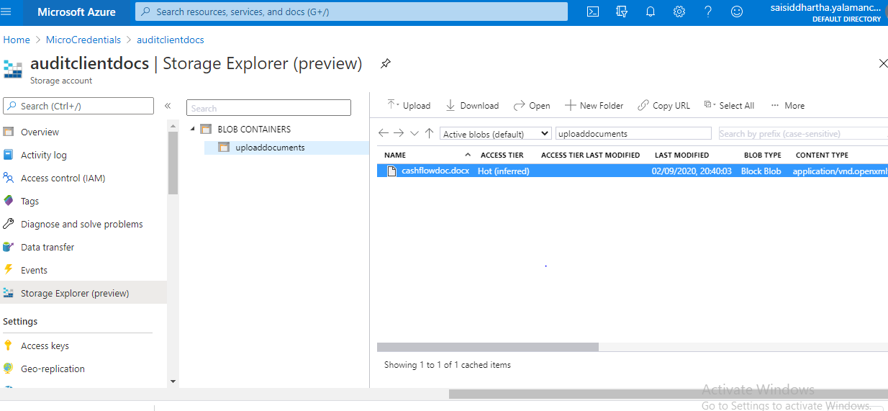

**AuditorService:**

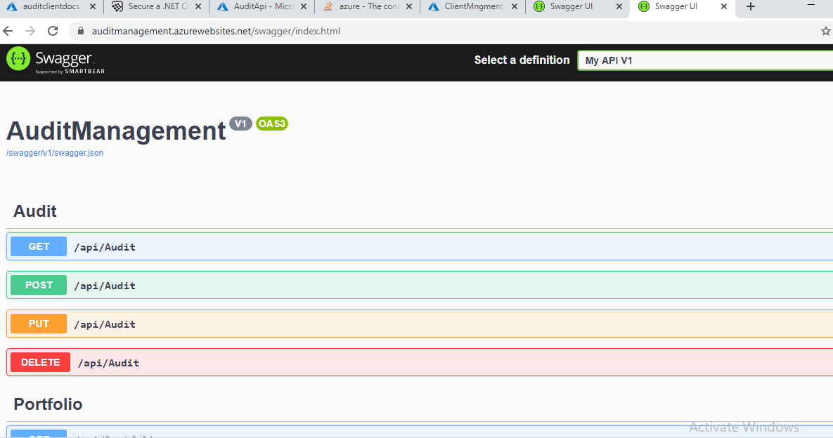

**ClientService:**

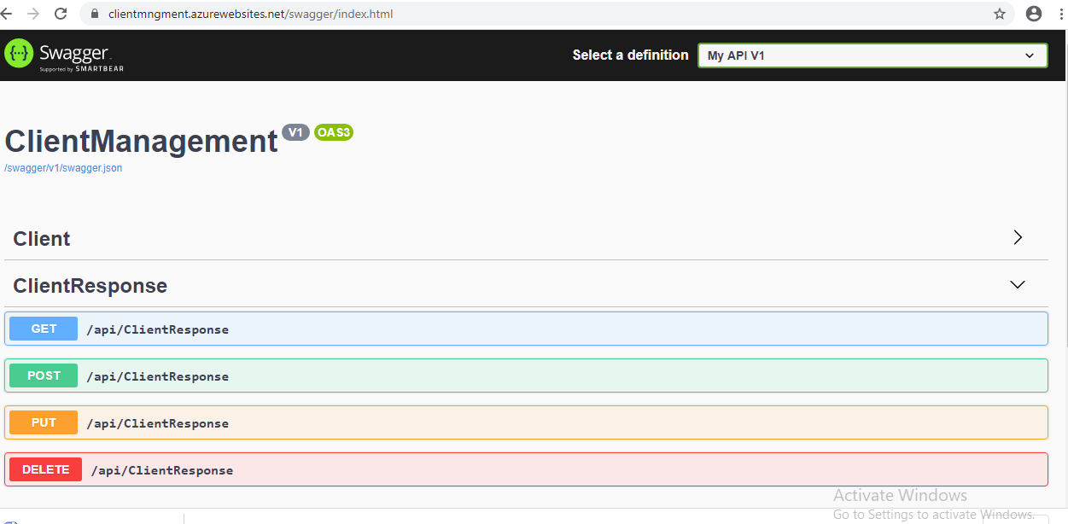

**Authentication and Authorization :**

**Concept used :** Jwt bearertoken with AAD

Created an Azure active directory with applications and security keys.

The Active directory issues tokens to the requests from clients.

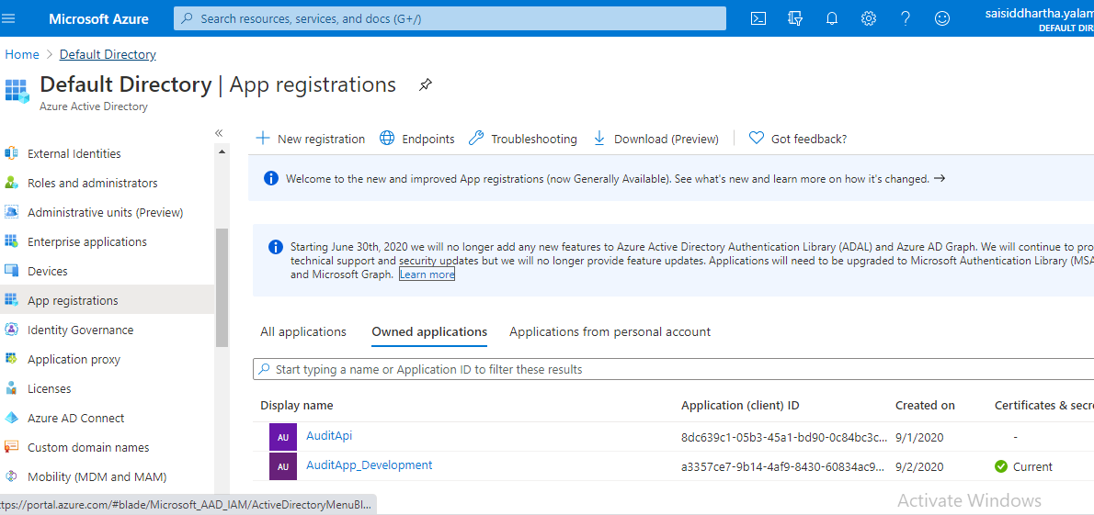

Below is an request from postman to the audit app for a get request. It returns 401 Unauthorized error.

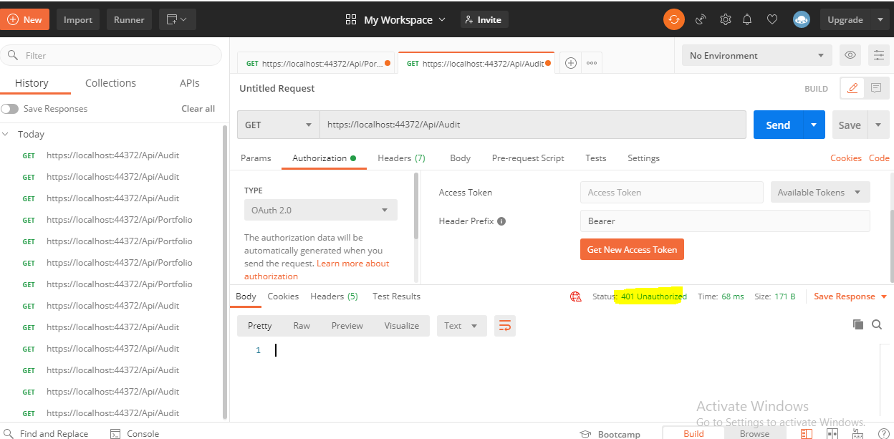

I’ve created a client application that generated tokens from AAD and gets the response as below.

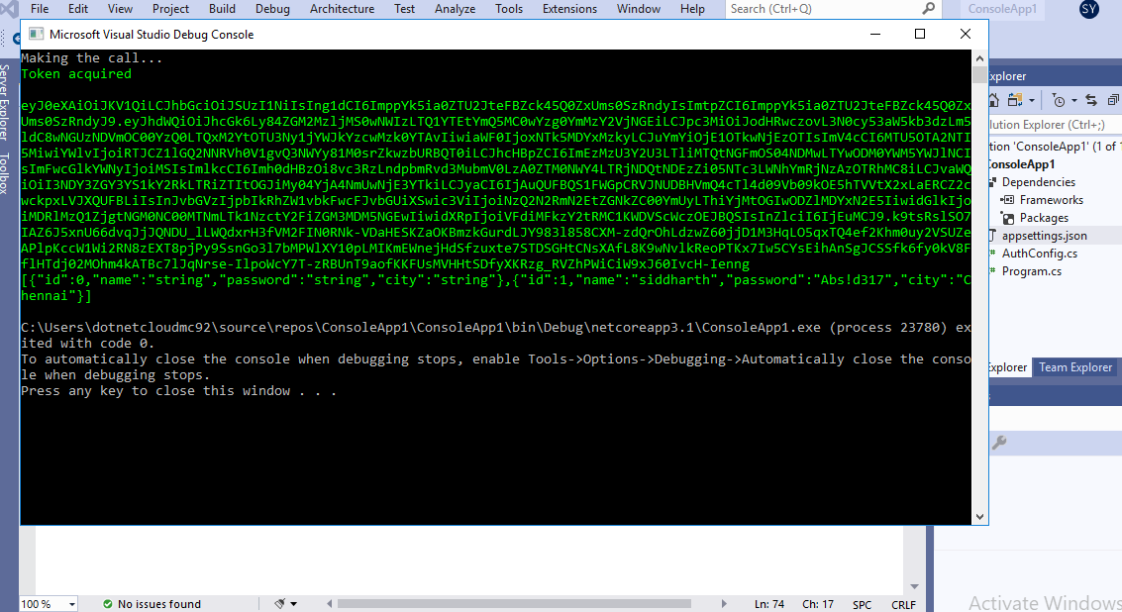

Git :

<https://github.com/sid-siddy/AuditApplication>

<https://github.com/sid-siddy/ClientApplication.git>